**Zara Mens Shirts**

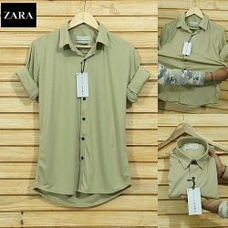

##### COLOMBIA GREEN POLYESTER SHIRT

PKR992.00

* **Size**: Medium
* **Color**: Green polyester

**MORE INFORMATION:**

* Wear Type: Semi-Formal
* Product Category: Shirts
* Volume : Volume 4 2021
* Collection: Festive Affair '22
* Fabric: cotton
* Size Available: Small , Medium ,Large
* Disclaimer: Due to the photographic lighting & different screen calibrations, the colors of the original product may slightly vary from the picture